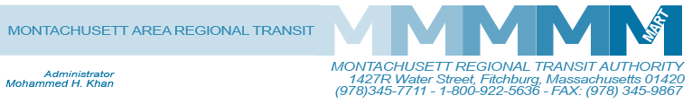

Posted 02/04/2014 at 9:27 am by JAV

MEETING OF THE MART Financial Oversight/Executive Compensation Committee
MART Maintenance Facility
1427R Water Street
Fitchburg, MA 01420

Thursday February 6, 2014
11:00 A.M.

Agenda

Finance Committee
• FY 14 Year-to-Date Actual
• Change in Accounting Practices-capitalization
• Fiscal Organization-skill sets, reorganization
• Banking Enhancements
• EOHHS, Full Compliance
• HST Statewide Broker
• MassDOT Internal Audit Interview, I/C, Procurement, Operator transparency
• Regional Intermodal Center
Compensation Committee
• Acting Administrator compensation recommendation
• Other Items: Step Alteration, H/R Director Role, Director of FP&A Role, Executive Compensation and Cost of Living
• Benefits GIC and State Retirement Implementation
Presentation Appendices

Adjournment
C: City and Town Clerks: Please post this notice pursuant to MA General Laws Chapter 30A,
Sections 18-25.

